Vision for Multiplication
See Chapter 3 in Global Church Planting – Biblical Principles and Best Practices (Ott and Wilson 2011)

Acts 19 A Case Study in Multiplication
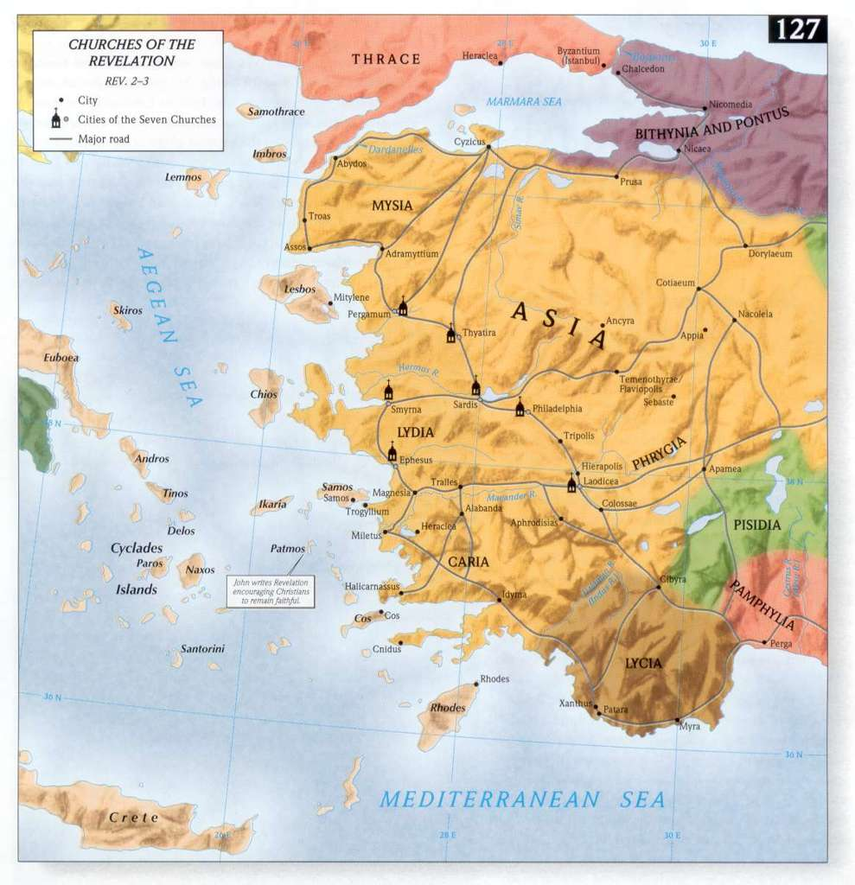
NIV Acts 19:10- 12 This went on for two years, so that all the Jews and Greeks who lived in the province of Asia heard the word of the Lord. God did extraordinary miracles through Paul, so that even handkerchiefs and aprons that had touched him were taken to the sick, and their illnesses were cured and the evil spirits left them.
1 Cor. 16:7-9, 19 I hope to spend some time with you, if the Lord permits. But I will stay on at Ephesus until Pentecost, because a great door for effective work has opened to me, and there are many who oppose me… (19) The churches in the province of Asia send you greetings. Aquila and Priscilla greet you warmly in the Lord, and so does the church that meets at their house.

Here are some foundations for multiplication that I see in the passage.

1) A strong but mobile church planting team. Apollos, Aquila & Pricilla do the ground work (Acts 18:24-26). Paul joins the team. Timothy and Erastus were also there for some time. The team is not stagnant. They move in and out.

2) A creative platform in an urban Center of influence - In Ephesus they penetrate diverse circles and networks with the Gospel: Greeks and Jews, religious people and sorcerers. In this urban center Paul found in the Hall of Tyrannus a creative platform, an easy access place, to reach many after leaving the synagogue. The Western text says Paul used this well-know lecture room from 11:00 a.m. to 4:00 p.m. (FF Bruce Acts, p. 388).

3) Intentional, sustained evangelism and disciple-making - Apollos and the 12 were seekers who had received John’s baptism (vs. 1-7). FF Bruce thinks they may have been part of the Ephesus synagogue and, later, have helped to launch the gospel movement. As Aquila and Pricilla taught Apollos more completely, he was able to teach others. They also reached others in the synagogue. As a result of the strong discipleship, there was a good critical mass of disciples.

4) Lay pastors and missionaries are trained and deployed – In Acts 20:19-21 we see Paul’s pattern of teaching (everything useful in both homes and in public). The elders functioned as lay pastors. Epaphras works in neighboring Colossae, Laodicea, and Hierapolis (Col 4:12-13). Tychicus is possibly form Ephesus (2 Tim 4:12).

5) Other churches launched from Ephesus - First Corinthians is written from Ephesus during this period (1 Cor. 15:32, 16:19). A cluster of churches is already established in Asia (1 Cor. 16:19). Hierapolis, Colossae, Laodicea, and probably all the churches of Revelation 2-3 are located with Ephesus in the Lychus valley. Miletus and Troas (Acts 20: 6-12, 13-38) are probably later daughter churches because God did not allow Paul to remain in Troas when he passed through earlier (Acts 16:8).

6) Holistic Ministry - The gospel is preached, people are healed and demons are cast out. There is a demonstration of the life and power of Christ that no one can deny. This cannot be neglected as a dimension of multiplication even though the specifics may not be replicable.

7) Special work of the Holy Spirit - Paul himself acknowledges that this was a special opportunity and work of God (1 Cor. 16:9). The opposition attests to the fact that a spiritual advance was taking place. We dare not look at strategic factors to the exclusion of vital spiritual dynamics and special movement-sized faith.

What is an Acts 19 place or movement?

In an Acts 19 movement the gospel penetrates in depth and breadth so that transformation take place and disciples, leaders and churches are multiplied.

- Gospel Penetration
- Disciples are multiplied
- Real Transformation on several levels
- Servant-leaders are developed, empowered and released
- Churches are established and reproduce

The impact of the Ephesus Church Planting Ministry (Acts 19-20) can only be fully appreciated when one realizes that the churches in Revelation 1-3 and others are located in the Lychos Valley near Ephesus and are a fruit of this work. Multiplication took place.

We can say multiplication is taking place when there is multigenerational indigenous reproduction. We can say that is a multiplication movement when it has reproduced to the fourth generation and no longer relies on outside resources.

- First generation: Trainer models and local leaders observe
- Second generation: Trainer equips and local leaders assist
- Third generation: Local Leaders lead and trainer coaches
- Fourth generation: Local leaders lead and trainer observes

The focus is not on rapidity of multiplication but on assuring that systems and processes are in place so that multiplication is part of the DNA of the churches and a core value of their leaders.

Multiplication Vision from ReachAfrica

An African story will help us illustrate what we have in mind about multiplying disciple-making churches, through multiplying the people who will train those who actually do the task. God has commanded us to make disciples among all peoples but many churches stop when they have one small spiritual family. The following story by David Kiamu illustrates the seriousness of disobedience and the blessing that comes with obedience.

Two brothers lived with their aging parents in a village till they reached manhood. One of them, the elder brother lived alone on his farm because he believed in being independent. His brother lived in the village with other people. They were expected by their aging parents and the customs of the land to get married and have children. This is how African villages keep their memories, and generations alive.

The elder of the two, even though he had reached the age to get married and have children, refused to take a wife and have children. He lived and worked alone. He never had children to continue his family name and line. One day, he became very ill. He had no one to take care of him. He died on his farm and was buried. He did not have children to do anything in his memory. His disobedience to his old and aging parents and the customs of the land helped to erase every memory of his from the face of the earth.

The younger brother at the right age took a wife. He and his wife had fifteen children within the first twelve years of their marriage. They cared for their children, worked very hard and taught them to live in obedience to the expectations of the customs of their community. They also encouraged their children to get married when they were adults and live in community too. Because of this advice, each of his eight boys and seven girls got married and each had ten children to their marriages. Their village was becoming a bit too small for them. They decided to start their own villages and bring up their own children in their villages. So, the eight boys began eight villages with their own children while the seven girls moved with their own husbands in seven other villages. They were a large community living in different places. When the younger brother became old, he had already had many grand children. His children and grand children celebrated his death, and to this day, the villages begun by him are growing. People from his villages are beginning their own villages today. His name is still on the lips of people today. He obeyed his parents and lived by the customs of the community. His memory lives on today.

How does this story relate to sterile and reproducing churches?

For what reasons do churches choose not to reproduce?

How about today? Do we position ourselves for multiplication? My observation is that when there is finally a breakthrough after the hard period of sowing and ground breaking, many church planters have no plan for multiplication and move into a survival mode maintaining the church activities, and caring for the people. They have not laid a foundation for multiplication.


Here are some ideas from a Latin American discussion group:

Catalysts or best practices. What would it take today?

- Equip, empower and release national workers
- Informal and Non-formal education for base training
- Special opportunities for movement leaders
- God’s timing and special work – Convergence – Kairos moment
- Proclamation of the gospel – abundant sowing
- Betting the farm – high commitment from missionaries and national leaders
- Strong followers of Jesus - disciple quality and commitment

Hinderances. Why haven’t we seen this happen more often?

- Mission structures that hindered movement
- Mission initiatives that were not owned by national church
- Leadership failures – moral, conflicts
- Missiology (church planting) based on addition and transfer from missionary to national pastor
- Departure of visionary missionary leaders
- Lack of indigenous, bi-vocational models
- Health issues in mission, national church
- Leadership style that favors control over empowerment
- Servant pastors who become controlling leaders
- Sometimes continuing investment too long or unwisely (need to shake the dust)

Some Steps to Consider

- Identify and study places where multiplication is taking place.
- Help existing church planting efforts to move toward multiplication in their vision and structures.

- Cast vision through teaching, coaching and by promoting multiple healthy models – house church, cell church, catalytic church.

- Develop a profile of a movement leader and seek to build relationships with younger leaders with that potential.

- Build missional partnerships with leaders and churches in the U.S. that want to leverage these Acts 19 movements.

- Develop Training Centers to foster local leadership networks and serve as a platforms for training (this may be a local church building if the pastor is a catalytic, empowering leader).

- Appoint a point-person who will coordinate this Acts 19 initiative and coach those who nurture individual partnerships.

Reflection and Review:

1. Which of the steps above are you currently involved in?

2. How does the Acts 19 vision apply to your church planting movement?

3. Where is multiplication starting to take place?

4. What would it take to see multiplication take place? (Compare your answers to those of the Latin American team above).

5. What is the next step toward Acts 19 multiplication?

6. How does the African parable speak to you or to your situation?

7. What obstacles need to be removed in order for multiplication to take place? (Compare your answers to Latin American team below)

For more information read Chapters 3 and 14 - Global Church Planting – Biblical Principles and Best Practices (Ott and Wilson 2011)

