Coaching Church Planters
See Chapter 17 Global Church Planting – Biblical Principles and Best Practices (Ott and Wilson 2011)

What is the Value of Coaching?

Church planting leaders are realizing that it is not enough to give church planters basic training. They need ongoing guidance while they are planting and reproducing churches. This can be done in several ways, but the approach that has biblical precedent and demonstrable effectiveness is a mentoring or coaching relationship with an experienced church planter. Another advantage to a coaching system is the church planter who has received coaching will see its value and be more likely to coach others. This contributes to multiplication.
In ReachGlobal our major ministry focus is to develop, empower and release leaders. Coaching is a way of coming alongside leaders in an empowering way. Coaches are not supervisors or bosses. They serve with an open heart and hand. They help planters focus on results. When an empowering approach is used development is maximized because planters remain responsible for their choices and the results of their efforts.

How is Coaching different from Mentoring and Discipling?
What is coaching? Coaching usually takes place between a coach and a player or a supervisor and a worker. It is coming alongside someone else to help them grow and succeed in what God has called them to be and do.

Coaching is helping others discover God’s plan for their life or ministry and cooperating with the Holy Spirit to see that plan become a reality. Bob L. Logan

We should make a distinction between mentoring and coaching. Mentoring is closer the discipleship; it is developing a disciple through the practice of spiritual disciples to become the kind of person God desires. In mentoring there is direct guidance, the mentor and mentee share a common environment (like a small group or common ministry), and there is frequent contact, usually several times a month.

Coaching is coming alongside someone who is serving God to help them be successful in their ministry. A coach may have a broader ministry and less frequency of contact, but in both cases a personal relationship of trust is needed. Coaching often begins with a mentoring relationship. Although church planting coaches cannot personally mentor all the church planters they work with, they can foster and facilitate mentoring relationships between experienced church planters and novices. They may be able to personally mentor a few church planters who live in close proximity but they will want to see that each new church planter is involved in a mentoring relationship.

What does it take to be a coach?
Coaching is not dependent on a specific gift-set. Rather coaches are those who love to invest in others and see them grow and succeed. However some spiritual gifts such as wisdom, encouragement, discernment and teaching can be very useful. Coaches must be empowering rather than directive or controlling. For this reason direct supervisors are usually not the best people to coach their workers. Often people ask if you have to have successfully planted a church to coach church planters. Not all successful church planters make good coaches; and some effective coaches have learned from their mistakes as more than their successes. The primary competencies needed to coach church planters effectively are a prayer ministry, an understanding of church planting, empathy for church planters, good listening skills, and the ability to ask strategic questions. Coaches must develop skill in building relations, managing them and bringing them to a healthy closure at the appropriate time.

Are there Best Practices for Coaching Church Planters?

Church planting coaches need not leave their church planting ministries. Instead we encourage experienced church planters who are competent to coach to tithe (give 10%) of their time to coaching one or two new church planters. This allows them to use their experiences, even their mistakes and multiply themselves. Since coaching is simple and transferable this can generate a coaching movement. To grow these coaches, it may become important to have a regional catalyst who trains and coaches the church planting coaches. Later we will share how this took place in Latin America (Coaching Movement).

Coaches need basic training just like church planters. However coaching is a lot simpler than church planting. In order to be effective this coaching relations requires:
- An agreement about how the coaching will take place and for how long. Expectations must be discussed honestly.
- Extended time together initially to build trust and understanding.
- Visiting the context and ministry of the planter to know his/her situation first hand. This generates trust.
- Regular meetings adapted to the church planter’s needs. A study has shown these should be a least monthly (Ed Stetzer 2008).
- Coaching relationships have a lifespan. At one point bothe coach and coachee should agree that God’s purposes have been accomplish and the coaching relationship can end on a positive note.

Coaching should have a dual focus: the church planter’s ministry and his life and family since many obstacles are personal. This balanced approach demonstrates care for the whole person without neglecting ministry advance.

How are Coaches Developed?
A good way to develop coaches is to identify pastors and planters who are good listeners and disciplers and desire to invest in raising up the next generation of workers. Coaching competencies have been identified so they can be used for assessment or self-assessment. The research was directed by a psychologist from Fuller Theological Seminary (and later Indiana University), Dr. Charles Ridley who also developed the widely accepted church planter assessment.
The Nine Basic Competencies:

Abiding in Christ  Self-assessing  Communicating | FOUNDATIONAL COMPETENCIES
Establishing  Supporting  Concluding | RELATIONAL COMPETENCIES
Diagnosing  Planning  Monitoring | STRATEGIC COMPETENCIES

Potential coaches (who have most of those competencies) are invited to a Coaching Clinic 101 to be exposed to the concept and value of Coaching, to practice the basic skills and receive tools to get started. Those who put those things into practice are potential coaches. They may want coaching to get started.
Some trainers can also serve as coaches but training and coaching are two different profiles. Trainers are communication specialists who like to disseminate truth; coaches are specialists in listening and asking reflective questions who like to come alongside others to help them find their own solutions.
Coaches are so important to the overall success of church planters that it preferable to have coaches ready when the training takes place.
Bob Logan has written a simple, practical book to help coaches, Coaching 101. By signing up to www.coachnet.org for one year a leader can have access an array of coaching tools and presentations. Our experience in Latin America is that coaches need to be coached as they begin their ministry. Here are the four steps we used to start a coaching movement:
- Learners read Bob Logan’s Coaching 101.
- Learners come to a Basic Coaching Clinic with a commitment and plan to coach 2 others.
- Apprentice coaches practice coaching and share their progress with a “coaching” coach.
- Those who have implemented coaching come together for an Advanced Coaching Clinic to discuss problems they have had.
- After a year of coaching they are recognized as coaches and given tools to train others.
The methodology and strategy developed by Logan and others may not be transferable but the basic idea of coaching as a way of giving to others what God has given you certainly is. In order for this to take hold, people need to see the patterns of face-to-face instruction, rabbinic modeling and life-on-life teaching, and mentor-mentee relationships in the Scriptures. The same biblical models are used for mentoring, discipling and coaching because they are all based on Hebraic rather than Greek patterns informal education.
Several excellent resources are available (see Bibliography). For more technical discussions of coaching and mentoring please ask for the article Developing Church Planters for the Harvest (Gene Wilson). For a practical introduction read Logan, Bob 2001. Coaching 101.

Example: A Coaching Movement
The following sequential training was used between 2006 and 2009 to equip coaches for Latin American countries.
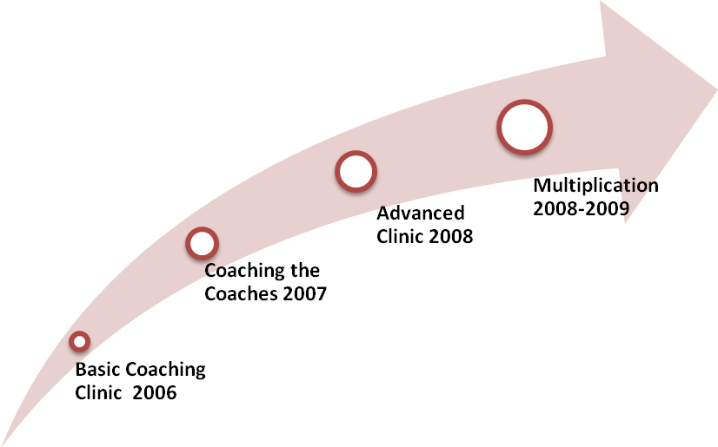
Fall 2005 - Each Latin America association was given a church planting coach profile and asked to select the person that fits that profile. In order to participate, delegates had to have at least two people who agreed to be coached.
Spring 2006 – The Basic Coaching Clinic was offered to those delegates. The movement leaders also received the training separately in order to understand and apply in leadership development. This was their request.
2007 – The new coaches applied the Basic Clinic to their coaching relationships. They were coached in this process. At the end of the year and assessment was done. Coaching difficulties and contextual issues we identified and used to design the Advanced Clinic.
Fall 2008 – Training focused on addressing obstacles and becoming more intentional in coaching. More advanced coaches also presented at the Clinic. We partnered with Church Based Training so coaching applications would be made to leadership development as well as church planting.
2009 – Coaching training was initiated in Costa Rica and Brazil, strengthened in Venezuela. In November 2009 the Coaches gathered again for a summit on training church planters. A Latino church planter training called “Apostolic Church planting – seven Steps” was presented and vision was cast for collaboration in a Missions movement for Latin America.

Themes covered in Coaching Clinic 101 and 201

The follow curriculum is given by way of example. However the sessions with a star as fundamental and could be covered in a 2-day Basic Clinic. We found in a relational culture like Latin America it was important to take more time, build relationships, discuss and practice together.

Coaching 101 | Coaching 201
*Design for Coaching (Definitions, Purpose & Vision) | Church-Based Training 1 – The Role of Pastor and Elders
*Coaching Skills (Listening & asking good questions) | Church-Based Training 2 - Coaching one of several tools in developing leaders
*Coaching Tools (agreement, guide, evaluation) | Coaching and Church Multiplication (Models of multiplication; how coaching facilitates reproduction)
*Coaching Relationship (build the relationship, cycle, dangers, ending the coaching) | Making Time for Coaching leaders (Making the transition from doing ministry to equipping others; time management)
Coaching System (Coaching as it relates to training & other movement systems) | Growing as a Coach (Intentionality, build a coaching ministry)
Coach as Facilitator (Areas where leaders often get in trouble and need coaching) | Improving your coaching skills (helping leaders discover, decide for themselves, and develop others)
Top Ten Church Planting Issues (Reasons why church planters fail. Coaching can help them deal with these key issues.) | Discussion: Most Common Coaching Problems and Solutions based on survey of coaches)

Reflection and Review

- Based on your reading and experience, write a church Planter Coach profile.

- What is the next step for you as a leader to model coaching and develop coaches?

- Who should lead the Coaching movement that will support church planting and multiplication?

- How many coaches will you need?

- How will the first generation of coaches be developed, empowered and released to reproduce themselves?

Other Resources
Clinton, J. Robert and Paul 0. Stanley. 1992. Connecting: The Mentoring Relationships you Need to Succeed in your Life. Navpress.

Cole, Neil. 1998. A fresh perspective of Paul’s missionary strategies. The Mentoring for Multiplication Model. Unpublished document.

Elliston, J. Edgar. 1993. Developping Leaders for Urban Ministries. N.Y. Peter Lang Publishers.

Logan, Robert L. and Sherilyn Carlton. 2001. Coaching 101. CRM Publications

Ogne, Steve and Thomas Nebel. 1995. Empowering Leaders through Coaching. A self-study kit. ChurchSmart Resources

_______. Tim Roehl, and Ed Stetzer. 2009. TransforMissional Coaching. Empowering Leaders in a Changing Ministry World. Nashville, TN: B&H Publishing.

Stanley, Paul and Robert Clinton. 1992. Connecting: The Mentoring Relationships You Need in life. NavPress

