The goal in this chapter is to think through what kind of leaders are needed and how they are developed.
Chapter 9
Developing Servants and Leaders
- The right kind of leader
- Leadership development principles
- Helping leaders grow and serve in culturally appropriate ways

In Christ’s kingdom leadership is not an end but a means
The following quotes are used in Ott and Wilson 2011 to underline the fact that in God’s economy leaders exist serve God’s purposes – edifying the church and bringing kingdom change into the world.
“Beware of traditional educational objectives which focus on educating a man. Biblical educational objectives seek to edify the church.” (Patterson 1981, 606)
“If we set out to produce a race of leaders, what we shall succeed in doing is probably to produce a race of restless, ambitious and discontented intellectuals. To tell a man he is called to be a leader is the best way of ensuring his spiritual ruin… (Stephen Neill, cited in Sanders 1989, 180)
“The need is not so much for leaders as for saints and servants, and unless this fact is steadily in the foreground, the whole idea of leadership training in Christian leadership becomes dangerous” (Sanders 1989, 180).

The kind of leader we seek to develop
No one says that leaders are not needed. To multiply healthy churches and fulfill the Great Commission many leader and the right kind of leaders are needed. Leaders are first of all disciples; but not all disciples are leaders. Within the pool of disciples some will emerge as leaders. When Jesus selected the twelve, he knew what was in the heart of man and had insights that church planters don’t have. We need visible evidences of the right kind of leader.
What measure of leadership will you look for? Some say integrity or character is all that is needed. Others look for people who are having an impact or influencing others. Still others look for people of initiative who have an entrepreneurial spirit.
Write down a descriptive phrase based on the verse you read.
Leaders who have been with Jesus - Acts 4:13 ______________________________
_______________________________________________________________________________
Workers in the harvest Matt. 9:35-38 _______________________________________
_______________________________________________________________________________
Leaders who serve Matt. 20:25-27 __________________________________________
_______________________________________________________________________________
Leaders who are role models 1 Pet. 5:1-4 ________________________________
_______________________________________________________________________________

Leaders who edify and equip Eph. 4:11-13 __________________________________

_______________________________________________________________________________

Leaders who give God their best Col. 3:23-24. ______________________________

_______________________________________________________________________________

Complete this summary statement. This is the kind of leader that we will pray for and seek to develop:

Here is a practical guide I have found helpful in selecting disciples who might be emerging leaders:
- Focus on men and women of INTEGRITY (character is key).
- Identify to ones that take INITIATIVE TO SERVE.
- Watch for those that have CREATIVE IDEAS and share them humbly.
- Emerging leaders want to LEARN and GROW in their ABILITIES.
- Because of these INNER QUALITIES they grow in their INFLUENCE.

Leadership Development Principles
Even those who say: “leaders are born, not made” will recognize that raw leadership talent must be honed, skills developed and character shaped. If you are serious about growing leaders you will identify through actual ministry situations those who prove “reliable” and “capable” (2 Tim. 2:2), and begin a training to further develop character, knowledge, skills and relationships.
How did Jesus tell us to begin finding workers (Matt. 9:35-38)? __________
______________________________________________________________________________
Notice that in was in the context of serving others that he told them to pray for more workers. What did he do immediately afterwards (Matt 10:1)? _______________________________________________________________________

Here are tested principles (from Mobilization for Multiplication).
Principle 1: Develop Broadly- Many leaders for many types and levels of ministry.
    - Give every disciple the opportunity to serve in some area whether small or great. Let them try several ministries. Then help them serve according to their gifts, calling and talents.
- Develop twice as many leaders as you need to allow for growth and church reproduction
Principle 2: Develop training that is specially designed for leaders
    - Gather them regularly in a leadership community for vision, encouragement and general training.
    - Provide specific training according to their calling and ministry function. Coaching will help them apply the training.
Principle 3: Prepare leaders for Mission
    - Think as much of the needs of the community as the needs of the body when preparing leaders.
    - Empower leaders to achieve the mission God has called them to.

Your turn: What other principles of leadership development have you observed?
1.
2.
3.

Helping leaders grow and serve in culturally appropriate ways
A leadership development ministry can be very simple. The lead church planter can combine personal mentoring and leadership community meetings to develop several emerging leaders. After a few months, as they prove to be faithful and capable, he would then help them select apprentices that they in turn would mentor and include in the leadership community.
Leadership development that works in one setting may back-fire in another culture. Here are some of the questions you might want to consider:
- What natural cultural patterns of communication, education or leadership development can be used (storying, initiation, mentoring)?
- What unbiblical cultural models of leadership need to be exposed and resisted (e.g. in Latin America caudillo and cacique leadership styles)?
- Are you familiar with Hofstede's notion of leadership power distance and its effects on leadership style and dynamics (See Ott and Wilson 2011 Chapter 17 and http://www.geert-hofstede.com/hofstede_dimensions.php
- What leadership styles from my culture must I avoid transposing to those I am working with (assertiveness, directness, time-focus, and business-bent)?
- How will we help emerging leaders identify and develop their spiritual gifts?
- What leadership needs and functions exist now? Which do we need to prepare for?
- What ministries outside of the emerging church fellowship will require leaders?
- How will we make equipping a priority and part of our ethos?
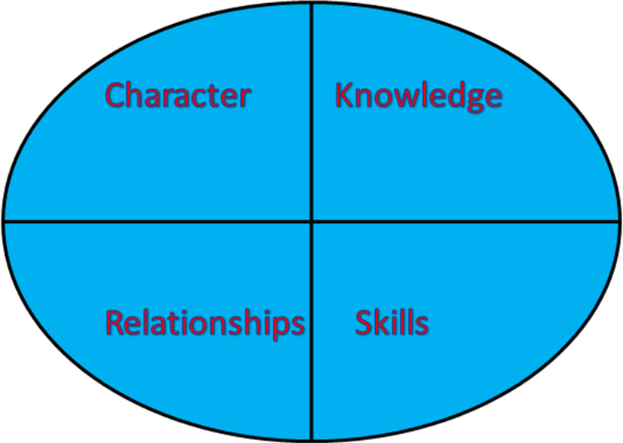
- How can we help emerging leaders grow in character, knowledge, skills and relationships?

Character:_____________________________________________________________________
Knowledge:___________________________________________________________________
Skills:__________________________________________________________________________
Relationships:________________________________________________________________
Consider the level-appropriate approaches to leadership development in Elliston’s Chart at the end of this chapter.
- What level(s) of leader will you be working with?
- What delivery system would be most appropriate?
- What resources are needed?
- Who will participate in the equipping process?
- Which of the following contexts could be used (See Ott and Wilson 2011 Figure 17.1: Equipping Plan for the North Munich Evangelical Free Church)?
  - Retreats
  - Classes
  - A leadership small group community
  - One-on-one mentoring
  - On-the-job coaching
  - Peer-mentoring in ministry teams
  - Informal discussions around the table
  - A sequence of workshops

Table 17.2
Development Distinctives for each Type of Leader
Curricular Issues | Type I & II | Type III | Type IV | Type V
Purpose | Small group leadership | Small congregation leadership | Large cong. or small Christian agency leadership | National / International leadership in administration, teaching or writing
Content | Specific skills & limited knowledge | Generalizable skills & knowledge, management skills | Knowledge of theories & theory application | Knowledge of theories and theory construction
Timing | Short cycle, at convenience of the learner | Long cycle, at convenience of the institution | Short cycle, at convenience of the learner | Short cycle, at convenience of the learner
Resources | Limited amount needed, usually available from the learner and the community being served | Resource intensive, many resources needed, often outside subsidies are needed | Moderate resources needed | Low to moderate resources needed
Costs | Minimal | High | Moderate | Low
Delivery System | Informal, modeling, apprenticeships | Formal, highly structured | More non-formal, less structured | Informal mentoring, apprenticed
Control | Partially external to the learner | Largely external to the learner | Increasingly self-selected | Self-selected or by agency served
Spiritual Formation | Focus on foundations and on doing | Focus moving from doing to being | Focus on converging status, role & giftedness | Focus on convergence
Elliston (1992,.35)
On a separate sheet of paper summarize your leadership development plan to develop servant leaders in your context.

A final word: There is a tendency to focus on the “squeaky wheel” and neglect the faithful and capable because they are doing so well. However a better approach is to challenge 2 Tim. 2:2 disciples to minister to new believers and needy people. Then you as church planter should come alongside them to help them succeed.
- Take them with you on visits.
- Observe them in group and ministry situations.
- Share and pray with them.
- Help them develop their spiritual disciplines.
- Affirm and encourage often.
- Correct gently as needed.
- Be more of a coach than a teacher to him or her.
This is the principle of working through apprentices: “Every problem can become an opportunity.”

